Intraspecific competition with evolutionary tradeoffs in a predator-prey relationship
Jake Campolo^{1,*}
* Corresponding author: campolo.j@husky.neu.edu | Phone (610) 389-8579
¹ 22 Marcella St Apt 1, Roxbury, MA 02119
Statement of authorship: JC designed the study, developed and analyzed the models, analyzed the data, and wrote the paper.
Keywords: predation, competition, metacommunity, phenotypic plasticity, tradeoff
Running head: Evolutionary tradeoffs | Type of article: Letter
Number of words in (abstract) manuscript: (130) 2038
Number of references: 7 | Number of figures: 4
Appendix A: The R code used to generate the results which are subsequently discussed in the manuscript

Abstract
Phenotypic plasticity enables prey species to acclimate to the presence of a predator by developing defensive traits, such as thicker shells on intertidal snails or defensive glands in plants. However, the evolutionary tradeoff in loss of reproductive ability is rarely studied. In this study I simulated the dynamics of a range of plant phenotypes, each with a distinct defensive strategy combining defensive ability and corresponding reproductive ability according to three types of tradeoff. The results show that the optimal defensive strategy to persist and coexist with a predator is that which retains all reproductive ability and forgoes any development of defensive ability. In an environment of intraspecific competition, it is a better strategy to out-reproduce and therefore out-compete other plant phenotypes than to develop defensive ability to resist the predator.

Introduction
As globalization and anthropogenic climate change increase, previously stable ecosystems are being threatened by invasive species and temperature rise. While these changes are on too small of a time scale to allow species-wide evolution, individual organisms in local communities are able to undergo a rapid acclimation in order to cope with a changing environment (Fussmann & Gonzalez 2013). This phenotypic plasticity takes form in several ways. Certain species of invasive arthropods are able to acclimate to higher temperatures in order to resist desiccation, a response to environmental change which allows them to outcompete existing species in the face of global temperature rise (Chown et al. 2007). Species are able to respond to the presence of a predator, during which a chemical cue from the predator can trigger the development of morphological defense. Intertidal snails developing significantly thicker shells in the presence of predatory crabs (Trussell 1996) and plants increasing their amount of defense glands relative to the amount of herbivores preying upon them (Agrawal 2001) are both defensive strategies adopted in order to resist predation and increase the likelihood of the species’ persistence.
While much of the research in phenotypic plasticity as it relates to predation focuses on the type and magnitude of the defensive trait increase, few address the questions of whether there are adverse effects to a species increasing its defensive ability and how this affects the population dynamics between the predator and prey in the long run. While gaining defensive ability from phenotypic plasticity is effective in reducing the number of species consumed by predators, evidence suggests that it comes at the cost of growth and reproductive ability in certain organisms, specifically in plant species. For plants in areas with high levels of resource availability, growth rate and secondary metabolism – responsible for herbivore-resistant defenses – are inversely related; the more nutrients being dedicated to defense, the less available for growth (Herms & Mattson 1992). Additionally, a greater presence of herbivores inciting an increase in defensive structures and a reduction in floral volatile organic compounds causes reduced attraction of plants to pollinators, leading to delayed flowering, lower seed production, and ultimately less reproduction (Schiestl et al. 2014). This evolutionary tradeoff implies that there is a possibility of dedicating enough resources towards developing a defensive trait that it has a negative effect on the plant species’ ability to grow and persist; moreover, there must be an optimal combination of defensive ability and reproductive ability which yields the most competitive plant species in a metacommunity in terms of persistence and relative abundance.
To determine the optimal defensive strategy in a predator-prey relationship, I used a spatially-explicit metacommunity model, consisting of a predator and a range of plant phenotypes which display intraspecific competition, in which colonization and predation were conditional on the plant species’ reproductive ability and defensive ability, respectively. The model was simulated with three different defense-reproduction tradeoff curves and three levels of predatory intensity. In this experiment it is revealed that the phenotype with the greatest survival ability is that which dedicates all resources to reproduction and none to defensive ability. Additionally, a lesser evolutionary tradeoff increases the equilibrium abundances of subdominant species, while varying predator strength has negligible effect on the overall model dynamics.

Materials and methods

Lattice parameterization
In order to simulate the dynamics between a predator and many different prey types, I used a spatially-explicit lattice featuring empty plots, 100 different phenotypes of a plant species, and one predator. The plant phenotypes are differentiated by their strategy, or combination of defensive ability and reproductive ability. These strategies are chosen from points along one of three tradeoff curves (Fig. 1). Defensive abilities (d) range from 0, meaning no defense, to 0.99. Corresponding reproductive abilities (r) ranging from 0.1 to 1 are determined using an equation based on the theta-logistic model (Sibly et al. 2005):
r = 1 - d^{θ}
Where θ is 0.25, 1, and 4 for Type 1, Type 2, and Type 3 respectively. The predator is given an attack intensity a, symbolizing its ability to overcome a plant’s defense, of 0.25, 0.5, and 1. Both plant species and predator were given a mortality rate of 15%. For this study, initial lattice conditions of 40% empty cover, 50% plant cover (divided evenly amongst the 100 different phenotypes), and 10% predator cover were chosen for a lattice of dimensions 64 x 64, and simulations were run for 350 time steps.

Lattice rules
The lattice is updated in discrete time steps according to two rules; one for plant species colonizing an empty plot, and one for a predator colonizing a plant species plot. Additionally, both plant and predator plots have the chance of returning to an empty plot based on their mortality rate.
For plant species colonizing an empty plot, the opportunity to colonize the plot is given to the strongest neighboring plant phenotype. Colonization strength S for each plant phenotype P neighboring the empty plot with reproductive ability r is determined by the following equation:
S = r * 1/8 ∑ P
The strongest neighboring plant phenotype colonizes the plot successfully according to a random probability determined by its reproductive ability.
For the predator colonizing a plant species plot, the plot is given to the predator if one of the neighboring plots contains a predator and if the predator’s attack intensity is greater than the plant species’ defensive ability.

Model analysis
The distinct plant phenotypes are chosen using three different curves to represent three primary types of response to a plant species increasing its defensive ability. The Type 1 curve represents a high tradeoff, or great loss in reproductive ability for each gain in defensive ability, Type 2 represents a neutral tradeoff, or even loss in reproductive ability for gain in defensive ability, and Type 3 represents a low tradeoff, where little reproductive ability is lost with initial increase in defensive ability. Defensive abilities range from 0 to 0.99 in order to maintain biological sense; it is possible for a plant species to have no defensive traits (d = 0), but an essentially invulnerable plant species (d = 1) is not feasible. Additionally, a defensive ability of 1 would yield a reproductive ability of 0, or inability to reproduce, which is also not feasible for this study. Similar to the variance in tradeoff type, predator attack intensity is varied to symbolize a weak, moderate, or strong predator (a = 0.25, 0.5, 1, respectively) in order to determine if predation strength affects the optimal defensive strategy for the plant species.
A plant’s colonization strength is density-dependent; it not only considers the reproductive ability of the neighboring plant phenotypes, but also their frequency. This is done to represent the idea that even if a plant has a lower reproductive ability, if it outnumbers its competitors by enough it can still have the greatest chance of colonizing an empty plot due to strength in numbers. However, the empty plot is still only colonized according to a probability based on its reproductive ability due to the fact that plants with poor reproductive ability may fail to persist in a plot even after gaining the chance to colonize it.
Predation is density-independent in this model for the sake of stability. If a predator neighbors a plant species and is strong enough to overcome its defense, it colonizes the plant plot. By updating according to these two colonization rules, the lattice model encapsulates the effects a plant phenotype’s phenotype has on its ability to reproduce and defend against predation.

Results

Optimal defensive strategy among distinct plant phenotypes
In every simulation, the most successful defensive strategy of the 100 different plant phenotypes was the strategy of developing no defensive trait at all and maintaining full reproductive ability (d = 0; r = 1). This plant phenotype outcompetes its competitors in approximately 5 time steps, after which it maintains a relative abundance of 8 – 10% while the other plant phenotypes either go extinct or survive with negligible abundance (< 1%). The dominant plant phenotype persists in equilibrium with the predator, which increases sharply in population in approximately 5 time steps, maintaining a relative abundance of 50 – 60% for the remainder of the simulation (Fig. 2, Fig. 3, Fig. 4).

The effect of tradeoff type on relative abundances
The effect of tradeoff type is most apparent in the relative abundances of the subdominant plant phenotypes. In each set of simulations, the vast majority of subdominant plant phenotypes go extinct in the Type 1 tradeoff plot, while their relative abundances are slightly higher in Type 2 and noticeably highest in Type 3, where they range up to 0.5% (initial abundance). A greater number of subdominant plant phenotypes persist in the Type 3 simulations than in the Type 1 and 2 (Fig. 2, Fig. 3, Fig. 4).

The effect of predation strength on relative abundances
The effect of predation strength is minimal to nonexistent in this experiment. Slight evidence of its effect can be seen in the ratio of equilibrium abundance between the predator and dominant plant phenotype. For a weak and moderate predator, the relative abundances of the predator and dominant prey are approximately 60% and 10%, respectively (Fig. 2, Fig. 3). However, in the simulations with a string predator the predator’s equilibrium relative abundance dips closer to 50% while the dominant prey’s increases to approximately 12% (Fig. 4).

Discussion
I have shown that given the opportunity to develop defensive traits at the cost of reproductive ability when confronted with a predator, the most competitive survival strategy is one which forgoes defensive ability completely in order to have maximum reproductive ability. While predator attack intensity had minor overall effect on the results of this experiment, varying tradeoff type determined whether subdominant plant species were able to persist at equilibrium.
At first it seems counterintuitive that a complete lack of defensive ability would yield the most survivable phenotype when exposed to predation. However, because each plant phenotype was competing with each other for space in the lattice, the strongest reproducer was able to quickly out-reproduce its competitors, and density-dependent colonization accelerated its population growth until it was the only substantial plant phenotype in the lattice. By that point, its lack of defensive ability did not matter because the model became a traditional one predator, one prey relationship, during which persistence is based on oscillations of the predator and prey abundances, not defensive ability. As can be seen in Figures 2, 3, and 4, predator abundance increases when prey abundance increases, which then causes prey abundance to decrease, immediately followed by a predator abundance decrease, mimicking the oscillations of the Lotka-Volterra predation model despite it being a spatially-explicit model.
The Type 3 tradeoff simulations feature greater persistence and higher abundances of subdominant plant phenotypes than in Type 1. This is due to the fact that Type 3 represents a low tradeoff, meaning that more species have a higher reproductive ability, allowing them to continue colonizing empty plots and maintain equilibrium with the predator. However, the abundance of the dominant plant phenotype prevents them from dramatically increasing in abundance.
Predation strength had little effect on the overall abundances of each species, except for slightly reducing the predator’s relative abundance. This is most likely due to the fact that the outcome of this experiment was largely determined by intraspecific competition in the plant species for reproducing in the first several time steps. Once one plant species dominated, the variation in plant defensive ability, and thus variation in the predator’s attack intensity, became insignificant. Predator strength and plant defensive ability would likely have a greater effect in an experiment pitting one plant phenotype against one predator in separate lattices for each phenotype.
Ultimately, the most competitive phenotypic strategy when defending against a predator is to outcompete other phenotypes with purely reproductive ability. In a metacommunity featuring a range of phenotypic plasticity responses to an invasive predator, developing defensive ability has a negative impact on a phenotype’s ability to persist in that environment. This conclusion can be used to influence ecological intervention techniques in ecosystems facing predatory invasion. Promoting the reproductive ability of a prey species, rather than the defensive ability, could yield a greater chance of success for the prey species in terms of persistence and coexistence with the predator.

Acknowledgements
I thank Professor Tarik C. Gouhier for teaching a rigorous and enlightening class as well as providing advice and support throughout the process of formulating and performing this study. I would also like to thank my peers in Ecological Dynamics for their helpful critiques of my project proposal.

References
Agrawal, A.A. (2001). Phenotypic Plasticity in the Interactions and Evolution of Species. Science, 294, 321-326.
Chown, S. L., Slabber, S., McGeoch, M. A., Janion, C. & Leinaas, H. P. (2007). Phenotypic plasticity mediates climate change responses among invasive and indigenous arthropods. Proceedings of the Royal Society of London B: Biological Sciences, 274, 2531-2537.
Fussmann, G. F. & Gonzalez, A. (2013). Evolutionary rescue can maintain an oscillating community undergoing environmental change. Interface Focus, 3, 20130036.
Herms, D. A. & Mattson, W. J. (1992). The Dilemma of Plants: To Grow or Defend. The Quarterly Review of Biology, 67, 283-335.
Schiestl, F. P., Kirk, H., Bigler, L., Cozzolino, S. & Desurmont, G. A. (2014). Herbivory and floral signaling: phenotypic plasticity and tradeoffs between reproduction and indirect defense. New Phytol, 203, 257-266.
Sibly, R. M., Barker, D., Denham, M. C., Hone, J. & Pagel, M. (2005). On the Regulation of Populations of Mammals, Birds, Fish, and Insects. Science, 309, 607-610.
Trussell, G. C. (1996). Phenotypic Plasticity in an Intertidal Snail: The Role of a Common Crab Predator. Evolution, 50, 448-454.

Figure Legends
Figure 1: Three types of tradeoff curve according to varying theta value in a quasi-theta-logistic equation. The parameter values are θ = 0.25, 1, 4 for Type 1, Type 2, and Type 3 and d ranging from 0 to 0.99 in 0.01 increments.
Figure 2: Relative abundances of each of the 100 plant phenotypes as well as the predator over in the spatial lattice model over 350 time steps, for each of the three tradeoff types (Fig. 1) and a weak predator. The predator is highlighted in red, and the most successful plant phenotype highlighted in blue. The parameter values are a = 0.25, mortality m = 0.15, and a distinct r and d between 0 and 1 for each plant phenotype as determined by the tradeoff type.
Figure 3: Relative abundances of each of the 100 plant phenotypes as well as the predator over in the spatial lattice model over 350 time steps, for each of the three tradeoff types (Fig. 1) and a moderate predator. The predator is highlighted in red, and the most successful plant phenotype highlighted in blue. The parameter values are a = 0.5, mortality m = 0.15, and a distinct r and d between 0 and 1 for each plant phenotype as determined by the tradeoff type.
Figure 4: Relative abundances of each of the 100 plant phenotypes as well as the predator over in the spatial lattice model over 350 time steps, for each of the three tradeoff types (Fig. 1) and a strong predator. The predator is highlighted in red, and the most successful plant phenotype highlighted in blue. The parameter values are a = 1, mortality m = 0.15, and a distinct r and d between 0 and 1 for each plant phenotype as determined by the tradeoff type.

Figures
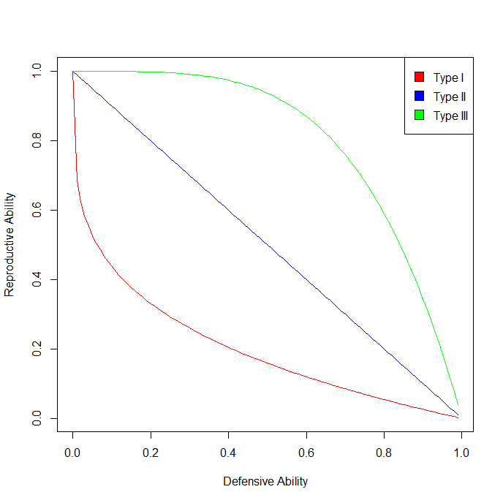
Figure 1

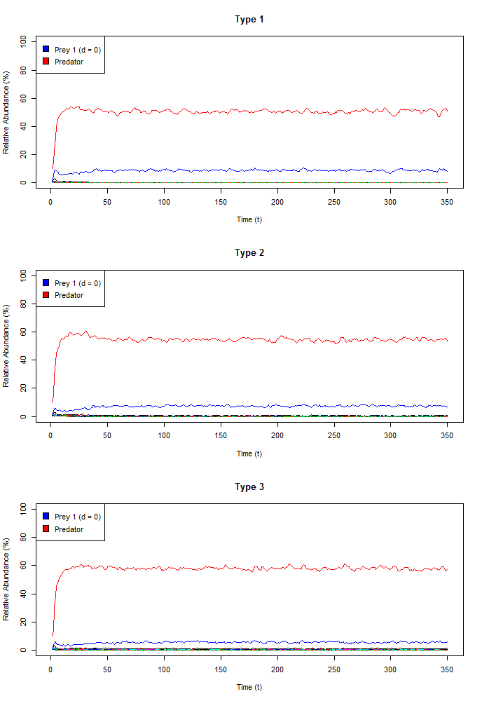
Figure 2
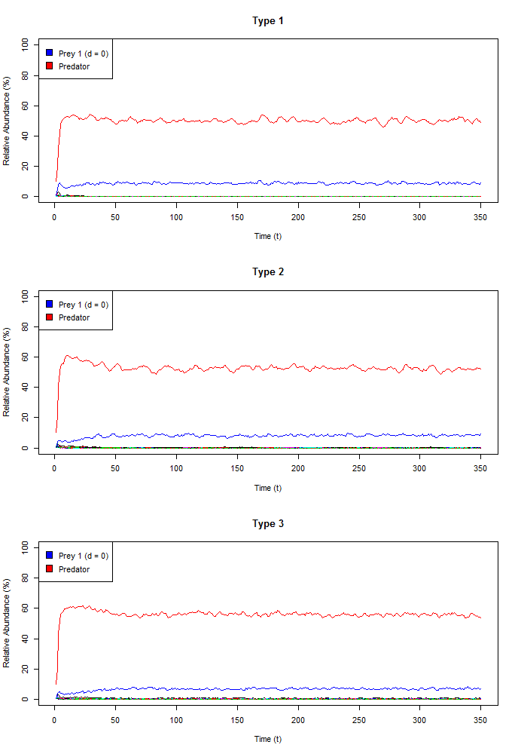
Figure 3
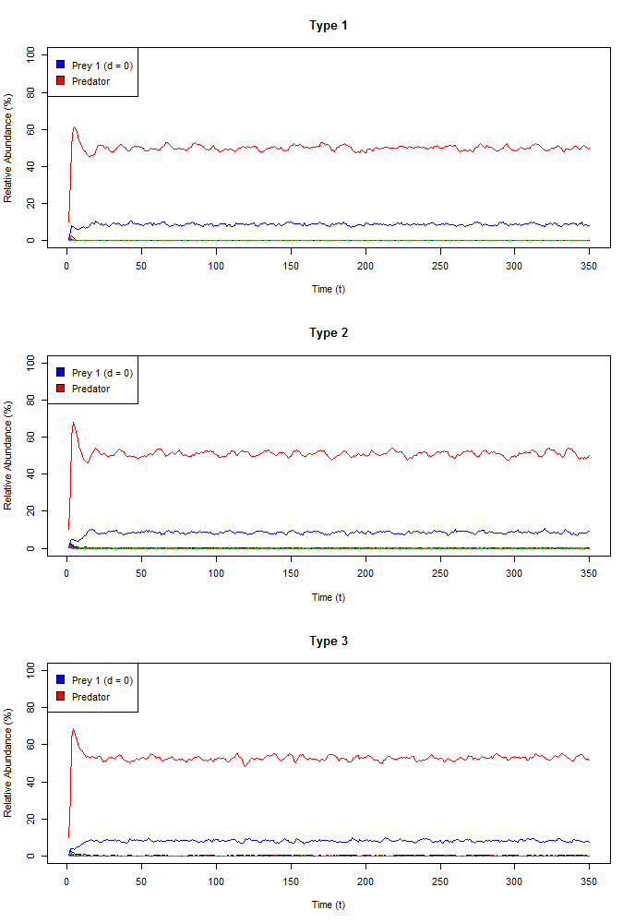
Figure 4

